[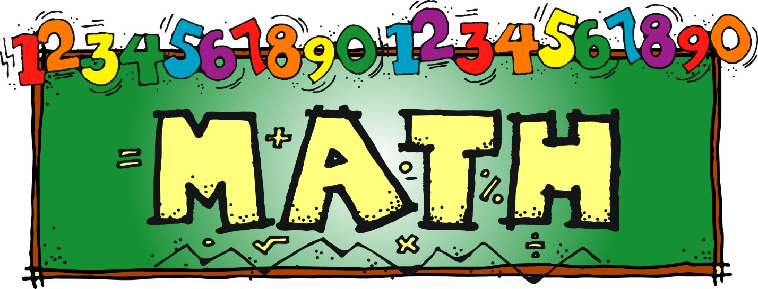](https://sites.google.com/a/ewrsd.k12.nj.us/emk-specialists/ms-smith/math)

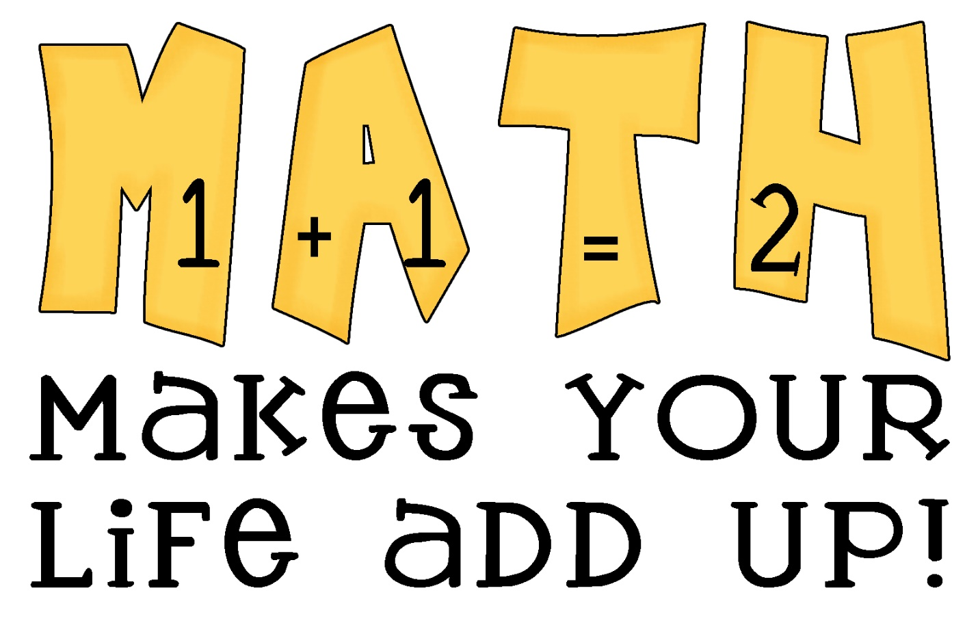

Fun Math game websites

1. <https://www.mathplayground.com/>
2. <https://www.coolmath4kids.com/>

Ideas for creating math games

1. Go Fish
2. Spoons
3. War
4. 24 Game

Math Worksheets

Third Grade: <http://www.k5learning.com/free-math-worksheets/third-grade-3/telling-time>

Fourth Grade: <http://www.k5learning.com/free-math-worksheets/fourth-grade-4/measurement>

Fifth Grade: <http://www.k5learning.com/free-math-worksheets/fifth-grade-5/fractions-decimals>

YouTube Math Lesson

<https://www.youtube.com/watch?v=4goOigrkdWI>

